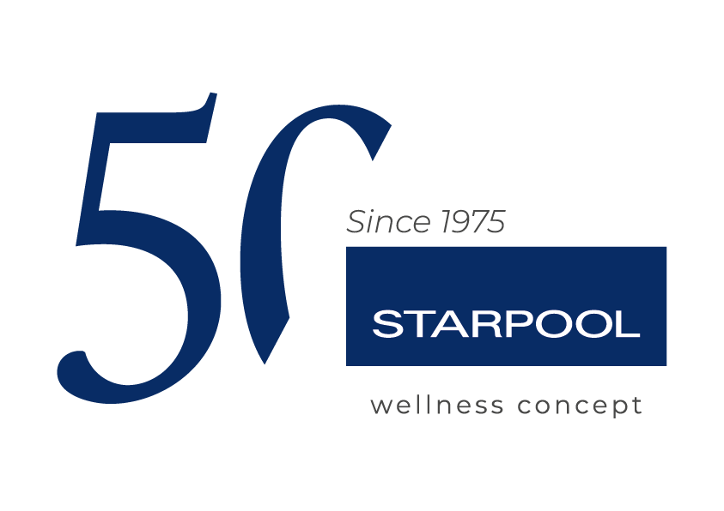

STARPOOL CELEBRATES 50 YEARS OF WELLNESS MADE IN ITALY

A journey of half a century between innovation and wellness culture



Ziano di Fiemme, 19th September 2025_ “Maybe, important anniversaries like this one allow us to retrace a long journey, made of many people who, with professionalism and dedication, have pursued a common goal: improving other people’s quality of life.
Now we need to look forward and go on with the same will to explore, capture and read the market trends in advance.”
— Riccardo Turri, CEO of Starpool.
In 2025, Starpool celebrates its first 50 years of business: it is an important milestone for a company that has been able to interpret the concept of wellness in a pioneer and multi-dimensional way. Founded by Ardelio Turri with the aim– declared in the original articles of association – to promote “the harmonious care and development of the human body”. In a time when this was barely spoken of, Starpool was able to combine an innovative vision of Wellness with the ancient traditions of Roman thermalism. It is right from this thousand-year-old heritage that Starpool’s DNA is inspired and transformed in the formula of heat, water and rest.
Under the governance of Paolo Turri, brother of the current CEO, the company started an actual innovation process with a far-sighted vision of the future. Today Starpool is run by Riccardo Turri – CEO and second-generation family member – who drove a new phase of growth focusing on Scientific Research and technological innovation, without ever losing sight of the iconic design that characterises its products.
From 1975, the year of the foundation as a plumbing and heating company, to the hand-crafted manufacture of the first steam bath in the family garage: over the last 50 years, Starpool has developed a varied portfolio of wellness solutions that now includes the entire spa sector, with Finnish saunas, steam baths, Mediterranean baths, sensory experiences and spaces of regeneration dedicated to body and mind. In the late 80s, the entry in the hospitality sector marked a new phase of the company’s evolution, which culminated in 2012 with the launch of sp.a_system®, the first scientific protocol based on the Starpool Method defining the fundamental rules to use spa equipment depending on the individual goals of health and wellness, and transforming the Wellness experience in a conscious practice oriented towards health.
Stress management, sleep, performance and longevity are the main drivers of global health, where the Wellness solutions by Starpool can have the best impact. They also represent the foundation of the company’s scientific research activity, carried out by an in-house department since 2021.

Today, Starpool is active in 86 Countries, with 22 distributors, 4 foreign branches and over 5.500 projects realised worldwide. The company works with internationally recognised architects and designers to create customised and high-performance Wellness experiences, with over 20.000 possible configurations. The solutions by Starpool can meet the needs of not only hotels, but also companies, gyms, professional athletes, medical and beauty centres. This is how the company manages to respond to the users’ growing desire for health: in 2023, it recorded a growth of 15% compared to 2022, and in 2024 the turnover exceeded €25 million (EUR 25.421.193), divided between private clients (26%) and business clients (74%).
55% of business comes from the Italian market, while 45% is abroad, 70% of which in the hospitality sector.

Thanks to its innovative technologies, Starpool works to combine innovation and well-being: from saunas to steam baths and Mediterranean baths, to one-of-a-kind prevention solutions, like the dry floatation with Zerobody Dry Float and the innovative Zerobody Cryo, the patented system that makes cold therapy accessible in a dry and non-invasive way. These solutions, developed on the basis of scientific research, are part of the Health Innovation product category by Starpool. They aim at mental and physical regeneration through the use of technologies that are cutting-edge but also versatile and easy to use.
With 16 registered patents and international partnerships of excellence – among which the Rockefeller Neuroscience Institute, the University of Brescia and Mapei sport – the company proves itself as one of the stars of scientifically-validated Wellness. Each Starpool project is designed to combine aesthetics, function and performance, turning every environment in a place of authentic regeneration thanks to an immersive and intuitive design.

The headquarters and beating heart of the company are at Casa Starpool, in Ziano di Fiemme: surrounded by the Dolomites, it is here that new projects and innovative ideas are developed. The company also promotes internal programs of prevention and daily well-being for the employees, favouring moments of mental and physical regeneration at work.
In 2025, year of the celebrations for the 50th anniversary, the company also saw the renovation of Casa Starpool Milano, the experiential showroom in Via Durini, in the heart of the Design District, where the general public can try first hand the innovations that join aesthetics, technology and wellness culture. This principle guides the approach of the company in the design of spaces dedicated to Corporate Wellness. “The more we are aware of our needs, the more we can contribute to improving our clients’. Wellness starts with us”.
Commitment to the environment is integral part of the company values. From the introduction of the Green Pack software, which enables a 20% reduction of the energy consumption of the spa equipment, to Eco Spa Technology, for the smart management of the wellness areas, Starpool takes forward a tangible commitment in terms of sustainability.
Right on the occasion of its 50th birthday, Starpool started Wood Recovery Project, with the goal to support the reforestation of the Fiemme woods, severely struck by Storm Vaia in 2018 and by a bark beetle pest, which has compromised the forest ecosystem further, thus threatening the biodiversity in the area. The devastation left by the storm strengthened Starpool’s awareness of its own responsibility towards the territory, which is one of the main pillars of its value system. With Wood Recovery Project, Starpool launches a broad five-year plan for the reforestation and protection of the territory, aiming to compensate for the environmental impact, but also to actively support the restoration of the natural balance in the woods of the Fiemme Valley.

A story of fifty years. An only mission: improving people’s quality of life, every day.

Press office DOC COM HUB

Francesca Riccardi| +39 335 77 00 526
Giorgia Giulianelli| +39 347 290 4699
Sara Degl'Innocenti | +39 3283019076

starpool.press@doccomhub.it - www.doccomhub.it

