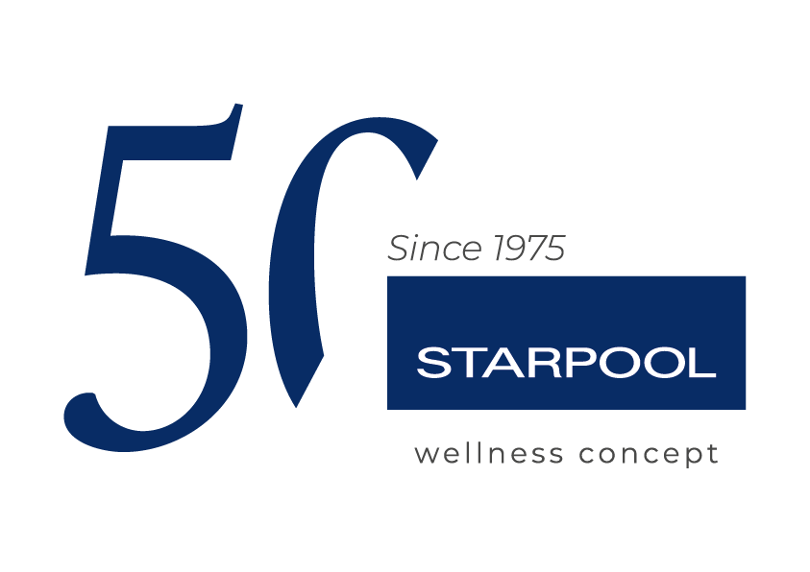

Marcell Jacobs and the importance of recovery in sports: working with Starpool to get back on track for the 2025 Tokyo World Championship.

The Italian sprinter chooses the technologies of the Fiemme company for his physical preparation

Ziano di Fiemme, 16th July 2025_ Recovery is no longer a passive moment during the training, but integral part of athletic performance. In running – especially at a competitive level – it can make the difference between a medal and an injury. Marcell Jacobs, Olympic 100 metres champion who recently had to slow down his preparation due to a muscle injury, knows it well.

The injury suffered to his thigh during a race in Miami in March 2025 forced him to interrupt competitions immediately and start a structured rehabilitation program. In view of the Athletics World Championship planned in September 2025 in Tokyo, Jacobs is following an intense recovery program supported by the medical team of the Italian Athletics Federation and by the technologies by Starpool, a Trentino company of excellence that has developed technological solutions for people’s and athletes’ psycho-physical well-being for 50 years.

“Recovery is no wasted time: it is part of the path that leads to victory”, wrote Jacobs on his social media social. “I am working daily to get back to top shape, without rushing things, but with utmost focus and determination.”

The rehabilitation program includes a combination of physical therapy, muscle strengthening, hydrokinesis, progressive work on the track and the use of innovative technologies developed by Starpool, among which Zerobody Cryo, Zerobody Dry Float and Molecular Hydrogen Booster. Cryotherapy, thanks to safe and localised cold application, is a valuable support in tackling inflammation and favour muscle recovery. Dry floatation, on the other hand, reproduces the effect of reduced gravity, thus promoting deep relaxation of the neuromuscular system and improving sleep quality. In the meantime, molecular hydrogen acts as a powerful antioxidant, supporting cognitive functions, reducing oxidative stress and contributing to cell regeneration. These solutions from the Health Innovation line by Starpool have been adopted by numerous athletes and sport teams, nationally and internationally, and are validated by the constant scientific research of the Fiemme company.

Jacobs’ progress will be carefully monitored through the constant evaluation of the rehabilitation program. The goal is to plan a gradual but effective return, allowing the athlete to recover his best physical condition without risks. This targeted approach aims to ensure the best possible shape in view of the World Championship. The attentive management of recovery time will be decisive to get ready for the most important event of the season.

This incident proves the importance of listening to one’s body, respecting its time and relying on solutions validated by science. In high-intensity sport disciplines like sprinting, an excessive load may compromise training continuity. This is why active recovery – supported by good practice in terms of nutrition sleep and mental well-being – is currently a critical pillar in top-level athletic preparation.

Jacobs and his team remain positive and determined. The champion is ready to write a new chapter of his career, but he will do so respecting his body and knowing that true strength – in sports as in life – lies not only in the power of starting, but also in the clarity of waiting.

Starpool - Wellness Concept made in Italy
For almost 50 years, Starpool has products and services designed to achieve mental and physical well-being. Focusing on the individual, with the goal of making wellness an accessible and daily practice, it creates spaces and programs to suit everyone, with the collaboration of designers, companies and operators in the sectors of hospitality, health, sports and beauty. All of this is done on the basis of a tailor-made wellness mission, for a customised wellness that makes its way in the home private world, as part of everyday life.
At the root of it all, there lies Starpool’s DNA: heat, water and rest, whose alternation generates genuine benefits that positively influence people's lives, from preventive care to muscle recovery, from the daily exercise to live well to mental wellness.
Casa Starpool is located in a true open-air spa, the Fiemme Valley, from which it draws constant inspiration in a continuous exchange, borrowing its raw materials, like the wood, and giving back a constant and daily commitment for a future in name of sustainability, starting with the development of innovative technologies for energy monitoring and saving.
With over 4.500 realised spas, Starpool is present in 83 Countries worldwide, with 4 foreign branches and 22 distributors.
http://www.starpool.com/

Press office DOC COM HUB

Francesca Riccardi| +39 335 77 00 526
Giorgia Giulianelli| +39 347 290 4699
Sara Degl'Innocenti | +39 3283019076
starpool.press@doccomhub.it - www.doccomhub.it

