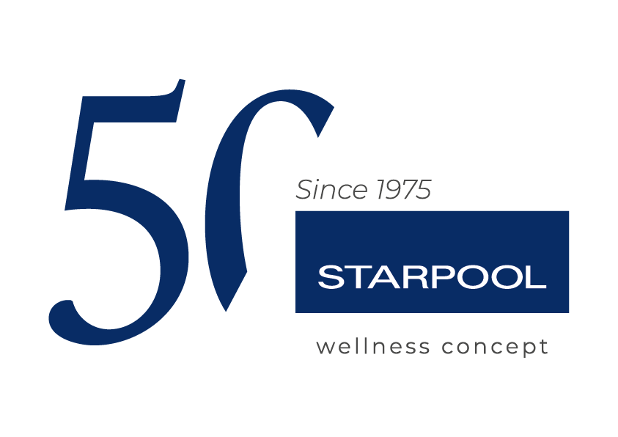

Starpool presents Wood Recovery Project:
the commitment for the rebirth of the Fiemme Valley

The Fiemme company started a five-year project for the protection of the biodiversity and recovery of the environmental balance of the Fiemme woods.

Ziano di Fiemme, 8th July 2025_ At the end of October 2018, Storm Vaia, an extreme weather event, hit the Italian North-East with high winds and persistent rain and fell tens of thousand of hectares of alpine and coniferous forest. A natural disaster that led to terrible consequences also in the Fiemme woods, among which a severe bark beetle pest that contributed to destroying the forest ecosystem further, thus compromising its biodiversity.

The devastation left by the storm strengthened Starpool’s awareness of its own responsibility towards the territory where the company originated and that has always been – together with the people and the innovation – one of the main pillars of its value system. The Fiemme Valley isn't just the place where the company grew, but also the main source of the raw materials used for the Wellness creations by Starpool. With Wood Recovery Project, Starpool launches a broad five-year plan for the reforestation and protection of the territory. The goal isn’t just to compensate for the environmental impact, but also to actively contribute to the restoration of the ecological balance of the woods of the Fiemme Valley, taking on the challenges connected to climate change and biodiversity preservation.

A PROJECT OF TRADITION AND INNOVATION
Started on the occasion of Starpool’s 50th anniversary, Wood Recovery Project was developed in collaboration with the forestry technicians of Magnifica Comunità di Fiemme with the aim to protect the woods of the Fiemme Valley with special attention for the Canzenagol biotope, a 16-hectare area protected by the European Union as it hosts a peat bog that is home to rare marsh species, amphibians and reptiles that can be found only there. The Canzenagol Biotope is a fundamental ecosystem for the water balance of the territory: it contributes to the regulation of natural resources and plays a key role in preserving biodiversity. In fact, the project is not limited to reforestation, but also aims to reduce hydrogeological risks, improve air quality and promote the recovery of the forest habitat.
The first phase of the project involves the recovery and removal of desiccated plants, in an operation of woods clearing that aims to protect the ecological balance of the peat bog. Peat bogs are among the so-called wetlands, and they house great biodiversity, purify water and trap a large amount of environmental carbon, thus fighting climate change. The removal of dessicated plants will be an essential step in ensuring tourists’ safety in the area. This intervention will pave the way for a second phase of reforestation in the surrounding area, protecting landscape and improving air quality. Special events will be organised to make the local communities and the tourists aware of the importance of forest protection, as well as a sustainable tourist itinerary and active preservation activities. The project is an example of environmental protection and responsible tourism, which will end with the installation of info boards to engage visitors in the safeguard of the ecosystem.

To add even more value to the project, Starpool chose to actively involve clients and stakeholders: for each sold sauna and for each guest welcomed at Casa Starpool and Casa Starpool Milan, the company will plant a new tree, thus contributing to a reforestation process that is both symbolic and tangible. Each plant represents a promise for the future and a step towards the regeneration of our ecosystem, a sign of hope for the planet and the future generations who will enjoy a healthier and greener environment.

STARPOOL FOR A SUSTAINABLE FUTURE

Wood Recovery Project is part of a broader sustainability approach that characterises every aspect of Starpool’s work. From advanced technologies aimed at energy saving in the realisation of spas and wellness centres to the continuous search of environment-friendly solutions, the company is constantly engaged in the promotion of responsible practices. The Wood Recovery Project isn’t just an eco-friendly intervention, but an actual corporate philosophy that integrates love for nature with the need to protect it, promoting global and lasting well-being.

Starpool’s commitment towards nature is an invitation to participate in a positive change. Each client, each guest visiting Casa Starpool or buying a sauna becomes integral part of this journey of recovery and rebirth. In fact, care for our territory has always been one of the pillars of the company philosophy. As highlighted by Riccardo Turri, CEO of Starpool: “Each one of our projects is a tribute to the nature that surrounds us, and a constant commitment towards its recovery and protection.” With each planted tree, Starpool contributes to a better, greener, healthier world.

Starpool - Wellness Concept made in Italy
For almost 50 years, Starpool has products and services designed to achieve mental and physical well-being. Focusing on the individual, with the goal of making wellness an accessible and daily practice, it creates spaces and programs to suit everyone, with the collaboration of designers, companies and operators in the sectors of hospitality, health, sports and beauty. All of this is done on the basis of a tailor-made wellness mission, for a customised wellness that makes its way in the home private world, as part of everyday life. At the root of it all, there lies Starpool’s DNA: heat, water and rest, whose alternation generates genuine benefits that positively influence people's lives, from preventive care to muscle recovery, from the daily exercise to live well to mental wellness. Casa Starpool is located in a true open-air spa, the Fiemme Valley, from which it draws constant inspiration in a continuous exchange, borrowing its raw materials, like the wood, and giving back a constant and daily commitment for a future in name of sustainability, starting with the development of innovative technologies for energy monitoring and saving. With over 4.500 realised spas, Starpool is present in 83 Countries worldwide, with 4 foreign branches and 22 distributors.
http://www.starpool.com/

Press office DOC COM HUB

Francesca Riccardi| +39 335 77 00 526
Giorgia Giulianelli| +39 347 290 4699
Sara Degl'Innocenti | +39 3283019076
starpool.press@doccomhub.it - www.doccomhub.it

